Project Name: Automatic Light Control

Introduction
The Automatic light control system
The Automatic Light control system is an progressive and energy-efficient solution that automates lights based totally on particular situations, including door activity. This system removes the need for manual switching by using the usage of a sensor-based mechanism that detects the opening or closing of a door. The layout guarantees that lights are activated most effective when essential, retaining energy whilst presenting comfort. stimulated by way of realistic implementations, this venture integrates simple yet effective components like a comparator, timer IC, and output devices. The system is ideal for use in homes, workplaces, and public spaces in which lighting fixtures automation is a concern.

Hardware used

- Door Switch (Normally Closed - NC):
  - Detects the door’s state (open or closed).
- Comparator (LM741 IC):
  - Compares the voltage from the door switch with a reference voltage to generate a HIGH or LOW output.
- 555 Timer IC:
  - Functions as a pulse generator to control the activation duration of the light or buzzer.
- Resistors:
  - R1 (10 kΩ): Pull-down resistor to stabilize the comparator input and prevent false triggering.
  - R2 (1 kΩ): Used with the 555 Timer to define the RC time constant.
  - R3 (470 Ω): Current-limiting resistor for the LED (if used as an output indicator).
- Capacitors:
  - C1 (10 µF): Smoothing capacitor for the power supply.
  - C2 (0.1 µF): Noise suppression capacitor near the ICs.
  - C3 (1 µF): Timing capacitor used in the 555 Timer to define the output pulse duration.
- 555 Timer Configuration:
  - The output pulse duration (time for which the light stays ON) is calculated using the formula:
T = 1.1 × R2 × C3
For example:
    - If R2 = 1 kΩ and C3 = 1 µF, the output pulse duration T = 1.1 × 1000 × 0.000001 = 1.1 ms.
Adjust R2 and C3 values based on the desired light activation time (e.g., longer durations require larger resistors or capacitors).
- Relay Module:
  - Switches the high-power load (light bulb or buzzer) based on the output of the 555 Timer.
- Light Bulb/Lamp:
  - Voltage Rating: 12V (or match it with the relay output voltage).
  - Power Rating: 5W or as required for your application.
  - Ensure the lamp's power matches the relay's capacity to avoid overloading.
- Buzzer (Optional):
  - Voltage Rating: 5V or 12V (depending on the system design).
- Power Supply:
- ICs and Logic Circuit: 5V DC (regulated).
- Relay and Light Bulb: 12V DC (for switching and output).
- Breadboard/PCB:
  - For mounting and connecting components.
- Connecting Wires:
  - For establishing electrical connections between components.

objective
The main objectives of this project are:

Automated light control:
To automate the switching of lighting fixtures based totally on door activity the usage of a sensor-based totally mechanism.
Energy Conservation:
Reducing electricity intake by using ensuring lights are only ON while the door is opened and off while the door is closed.
Low-cost Implementation:
To design a device using low-cost and easily available electronic additives.
Ease of installation:
To increase a device that may be installed in any environment without complex configurations.
Scalability:
To enable future upgrades like integrating motion sensors or ambient light sensors for greater advanced control.

Block Diagram

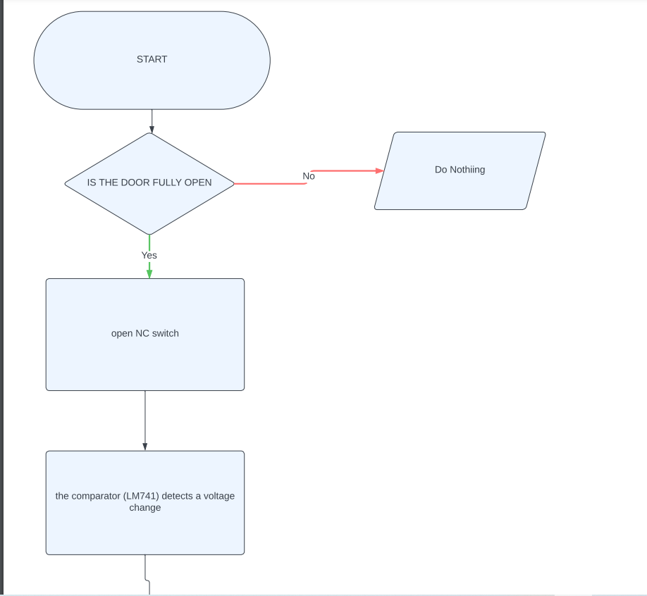
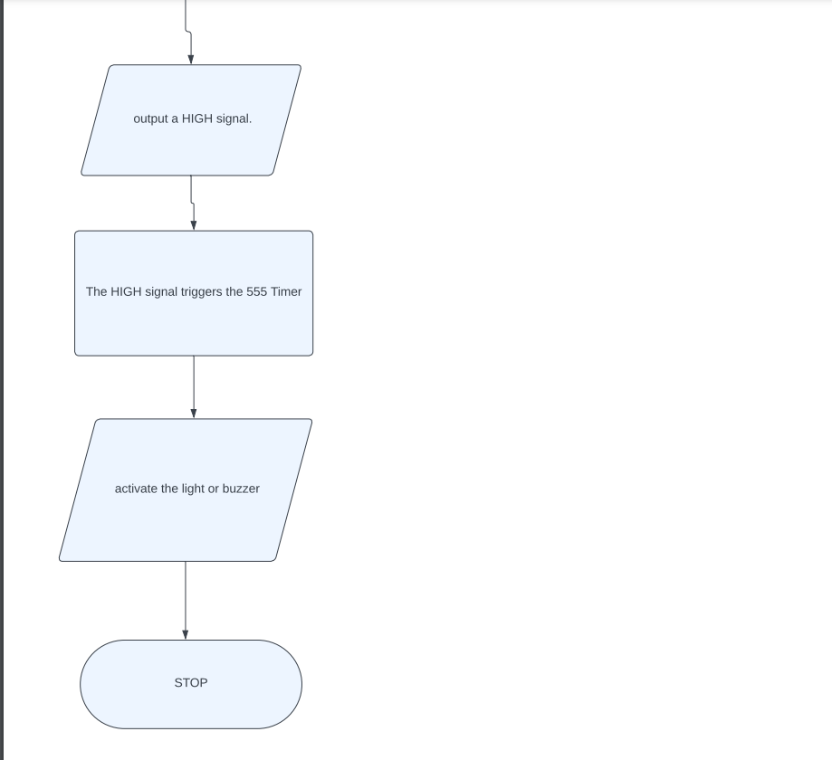

Methodology
- Setup the Door Switch (NC):
  - Mount the switch at a position where it opens only when the door is fully pushed against the wall.
  - Ensure proper wiring from the switch to the comparator circuit.
- Comparator Design:
  - Use the LM741 operational amplifier.
  - Set up one input of the LM741 with a reference voltage.
  - Connect the other input to the door switch's output to detect voltage changes when the switch opens or closes.
- Timer Circuit Configuration:
  - Use the 555 Timer IC in monostable mode.
  - Connect the output of the comparator to the trigger input of the timer.
  - Configure the timer to maintain the output (light/buzzer) active for a predefined duration.
- Output Stage:
  - Connect the 555 Timer's output to the light or buzzer circuit.
  - Ensure the light or buzzer activates when the timer output goes HIGH.
- Testing:
  - Open the door fully and observe if the light/buzzer activates.
  - Ensure the light/buzzer turns off after the timer's duration.
  - Test the system when the door remains closed to confirm no false activations.
- Finalization:
  - Fine-tune the timer's duration as required.
  - Securely mount all components and ensure reliable operation under different conditions.

